Post Safety Dossier

SAFETY HYGIENE ERGONOMICS

PROCESS: US2 N-Central Shops & Equipment

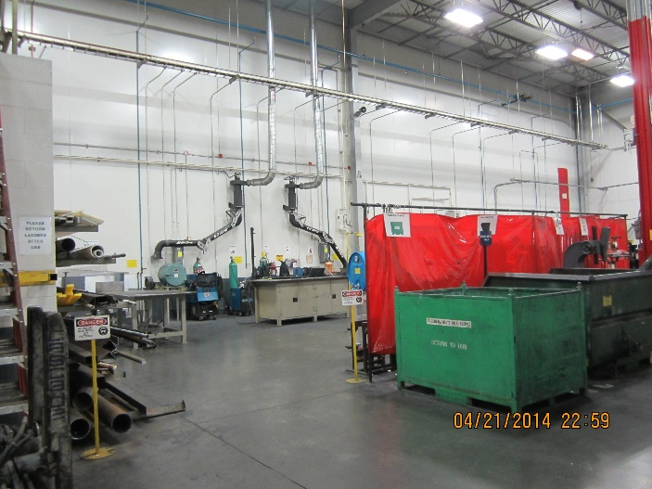

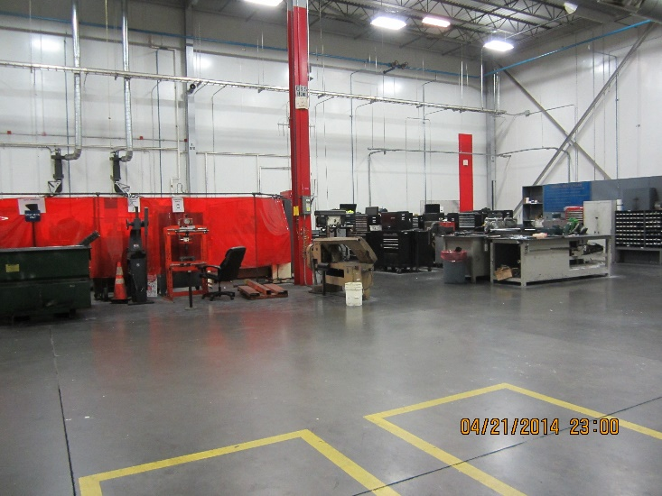

Process Step: US2 N-Central Shops & Equipment
2 - Outline of the Dossier for US8
N Central Shops & Equipment

Sections:

- 1 - General View of the Shops

- 2 - Outline of Dossier contents

- 3 - Responsibilities

- 4 - Record of revisions

- 5 - List of US8 N-Central – Mechanical, Machining, Fabrication, Repair and Electrical Shops Equipment w/PPE requirements and other instructions!

- 6 - Hazards encountered while operating machines in NC

- 7 - Safety rules

- 8 - Reflex Action Sheets

- 9 - Document Links

 | 3 - Responsibilities | Date: 18 June 2014

 | Function
Updating the PSD prevention dossier for the process step | Shop Trainer
Validation of changes | BUL
Accessibility of dossier on the post | BUL
Monitoring of safety devices – PV1 & PV2 | BUL

4 - Record of revisions

Date | Nature of the modifications | Parts modified | Author
18 June 14 | Create the document | All | N. Ebernickle EP
26 Oct. 15 | Revised pg. 36 “PPE Requirements” | Pg. 36 | R. Butler EP
18 Aug 19 | Addition of Coactivity Reflex Action and Lifting Equipment Reflex Action | 8 | B Wires, EP
23 Jan 26 | Retention / File Location Updates | All | J Lemler BIB Std

List of US2 N-Central – Mechanical, Machining, Fabrication, Repair and Electrical Shops Equipment w/PPE requirements and other instructions!
Some of the equipment shown on this list requires special training to safely operate. It is never permitted that you attempt to operate any of the identified equipment if you are not certified.

All Drill Presses – PPE = safety glasses & gloves (use caution when placing gloved hands near chuck or drill bit).
- Make sure work is properly secured
- If so equipped, make sure feed/speed is set correctly

All Presses – PPE- safety glasses & gloves (note: the 15 ton press requires Certification)
- Make sure work is properly secured
- If so equipped, make sure pressure is set correctly
- If so equipped, make sure the safety cage is properly closed
- If using broaching press in machine shop, use caution when operating pull handle so that it doesn’t fall and make contact with operator or others
- Make sure hands are clear when beginning to apply pressure when using the broach press

All Pedestal Grinders – PPE = safety glasses, face shield & gloves (use caution when placing gloved hands near grinding wheel)
- Prior to use, make a visual inspection of the grinding wheel looking for damage or misuse
- Make sure the gap between the work rest and the grinding stone is set at 1/8 “
- Make sure the gap between the guard and the grinding stone is set at ¼”

Bead Blaster – PPE = safety glasses, hearing protection
- Make sure the viewing glass is clean
- Make sure the access doors are closed and latched
- Make sure the aspiration is running
- Make sure there are no holes in the protective gloves

All parts washers – PPE = safety glasses & latex gloves
- Make sure the washer nozzle is pointed in a safe direction before starting the machine
- Use the correct cleaning tools (brush, scraper, scotch brite, etc.) no rags!
- Be sure to turn off power when finished!
- No open flames near parts washer

All Overhead Cranes – PPE = safety glasses & gloves
- Certification is required prior to using any overhead crane
- Use caution when moving any crane, crane trolley or the lifting hook
- Make sure the crane lifting capacity is not exceeded (capacity listed on crane)
- Inspect all lifting devices prior to use
- Use proper lifting devices: chokers (steel or nylon), spreader bars, etc.
- Make sure load is balanced before lifting with any crane

Rigid Pipe Threading Machine – PPE = safety glasses & gloves
- Make sure work is secured in chuck
- Make sure threading die is properly adjusted and secured
- Set coolant flow
- Observe and control thread length

Acetylene Welding – PPE = safety glasses (correct welding lens) & gloves
- Certification is required to operate acetylene rigs
- Correct setting on oxygen/acetylene gauges
- Cold fire extinguishing agent present
- All gasses turned off when not in use
- Fire watch in place

Electric Welding (MIG, TIG, HELI ARC, PLASMA) – PPE = Welding hood (with correct lens) & gloves
- Certification is required to operate welding machines
- Protective clothing as necessary
- Arc flash protection in place to shield surrounding areas
- Machine controls to correct settings
- Fire watch in place & cold fire extinguishing agent present

Notes:

- Unless otherwise specified, all E-Stops on US2 NC equipment are reset by pulling to release!

- If certification is required to operate a particular machine, contact your BUL to discuss your authorization prior to attempting to operate that machine or piece of equipment for the first time!

- When using hand tools to maintain or adjust any machinery in the NC shop first make sure the tools are in good condition and that you have sufficient clearance around the work area to perform the task safely.

6 – Hazards encountered while operating Equipment in NC @ US2

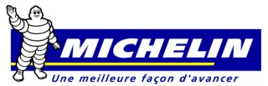 | PROCESS STEP: NC US2 |  | Activity: Operation of Equipment
LOCATION | HAZARDS IDENTIFICATION |  | INSTRUCTIONS – PRECAUTIONS | PREVENTION METHOD | Operational Management
Insert Picture w/Title | Hazard Icon | Written Description of Risk | Short Instruction | Prevention | PV1
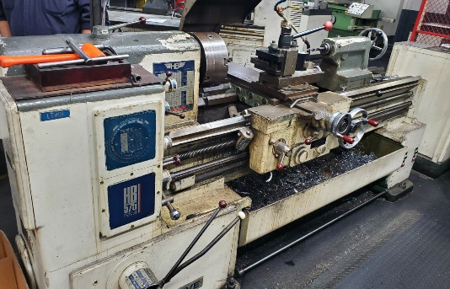  Metal Lathe |  | Risk of metal shavings in eye or cut by metal shavings. Hand injury risk if not careful when operating machine. | Certification is required to operate  Wear PPE as required. Make sure work, cutting tools and other attachments are secure. Set feed/speed according to consigne. | Apply practical knowledge and lessons from AP! | AP Training, Post Training, Post Safety rules
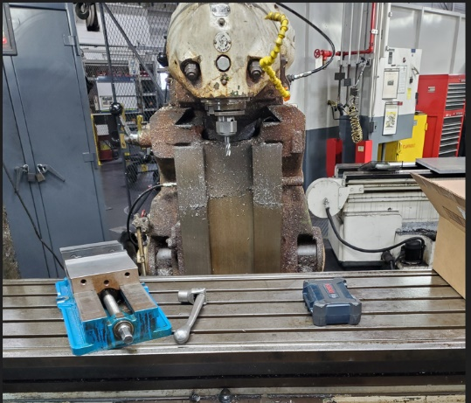  Milling Machine |  | Risk of metal shavings in eye or cut by metal shavings. Hand injury risk if not careful when operating machine. | Certification is required to operate  Wear PPE as required. Make sure work, cutting tools and other attachments are secure. Set feed/speed according to consigne. | Apply practical knowledge and lessons from AP! | AP Training, Post Training, Post Safety rules
 |  | Risk of metal shavings in eye or cut by metal shavings. Hand injury risk if not careful when operating machine. | Certification is required to operate  Wear PPE as required. Make sure work, cutting tools and other attachments are secure. Set feed/speed according to consigne. | Apply practical knowledge and lessons from AP! | AP Training, Post Training, Post Safety rules
  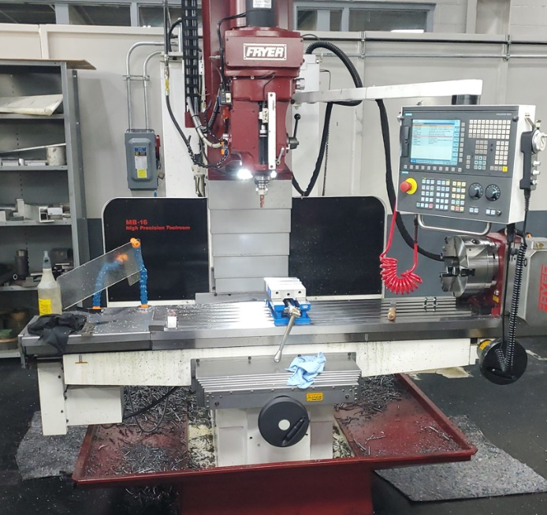  CNC Machining Center |  | Risk of metal shavings in eye or cut by metal shavings. Hand injury risk if not careful when operating machine. | Certification is required to operate  Wear PPE as required. Make sure work, cutting tools and other attachments are secure. Set feed/speed according to consigne. | Apply practical knowledge and lessons from AP! | AP Training, Post Training, Post Safety rules
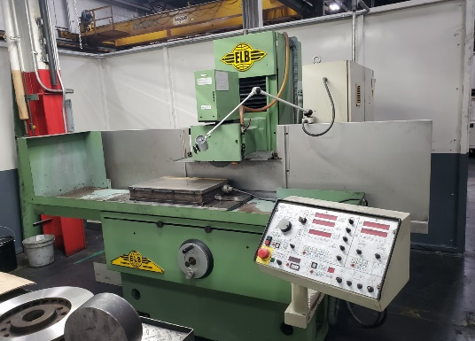  Surface Grinder |  | Risk of metal shavings in eye or cut by metal shavings. Hand injury risk if not careful when operating machine | Certification is required to operate  Wear PPE as required. Make sure work, cutting tools and other attachments are secure. Set feed/speed according to consigne. | Apply practical knowledge and lessons from AP! | AP Training, Post Training, Post Safety rules
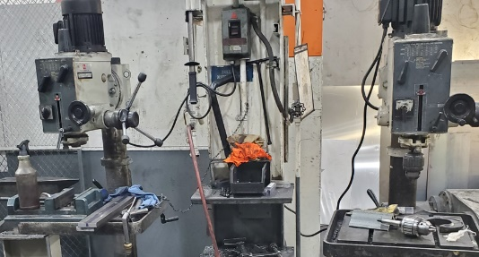  Drill Press |  | Risk of metal shavings in eye or cut by metal shavings. Hand injury risk if not careful when operating machine. | Certification is required to operate  Wear PPE as required. Make sure work, cutting tools and other attachments are secure. Set feed/speed according to consigne. | Apply practical knowledge and lessons from AP! | AP Training, Post Training, Post Safety rules
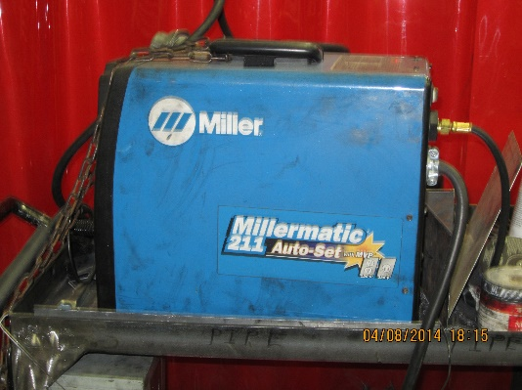 |  | Risk of damage to eyes or weld splatter burns.  Apply practical knowledge and lessons from AP! | Certification is required to operate  Wear PPE as required. | AP Training, Post Training, Post Safety rules | Post Training, Post Safety rules
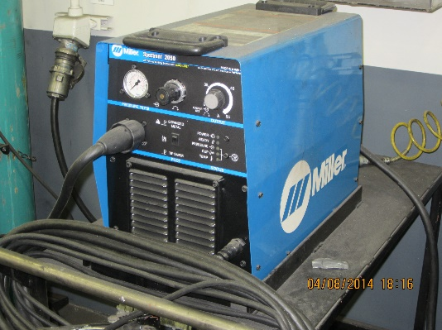 |  | Risk of damage to eyes or weld splatter burns.  Apply practical knowledge and lessons from AP! | Certification is required to operate  Wear PPE as required. | AP Training, Post Training, Post Safety rules | Post Training, Post Safety rules
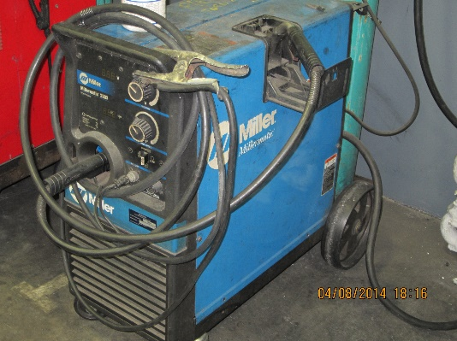 |  | Risk of damage to eyes or weld splatter burns.  Apply practical knowledge and lessons from AP! | Certification is required to operate  Wear PPE as required. | AP Training, Post Training, Post Safety rules | Post Training, Post Safety rules
 | PROCESS STEP: NC US2 |  | Activity: Operation of Equipment
LOCATION | HAZARDS IDENTIFICATION |  | INSTRUCTIONS - PRECAUTIONS | PREVENTION METHOD | Operational Management
Insert Picture w/Title | Hazard Icon | Written Description of Risk | Short Instruction | Prevention | PV1
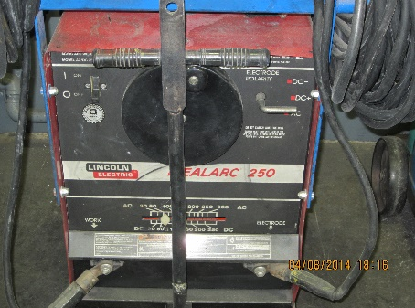 |  | Risk of damage to eyes or weld splatter burns.  Apply practical knowledge and lessons from AP! | Certification is required to operate  Wear PPE as required. | PPE, training, attention to detail, AP Training, Post Training, Post Safety rules | Post Training, Post Safety rules
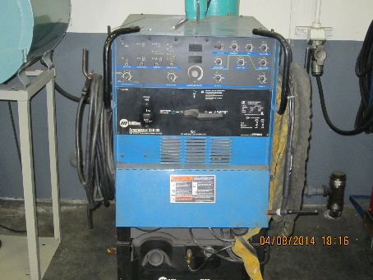 |  | Risk of damage to eyes or weld splatter burns.  Apply practical knowledge and lessons from AP! | Certification is required to operate  Wear PPE as required. | PPE, AP Training, Post Training, Post Safety rules | Post Training, Post Safety rules
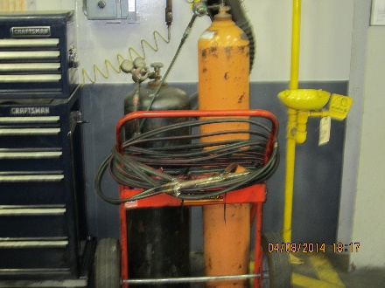 |  | Risk of damage to eyes or weld splatter burns.  Apply practical knowledge and lessons from AP! | Certification is required to operate  Wear PPE as required. | PPE, AP Training, Post Training, Post Safety rules | Post Training, Post Safety rules

 | PROCESS STEP: NC US2 |  | Activity: Operation of Equipment
LOCATION | HAZARDS IDENTIFICATION |  | INSTRUCTIONS – PRECAUTIONS | PREVENTION METHOD | Operational Management
Insert Picture w/Title | Hazard Icon | Written Description of Risk | Short Instruction | Prevention | PV1
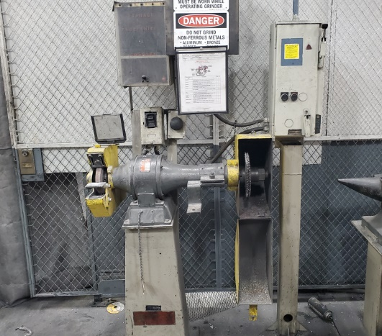  Bench Grinder |  | Risk of metal shavings in eye or cut by metal shavings. Hand injury risk if not careful when operating machine. | Certification is required to operate  Wear PPE as required. Make sure work, cutting tools and other attachments are secure. Set feed/speed according to consigne. | Apply practical knowledge and lessons from AP! | AP Training, Post Training, Post Safety rules
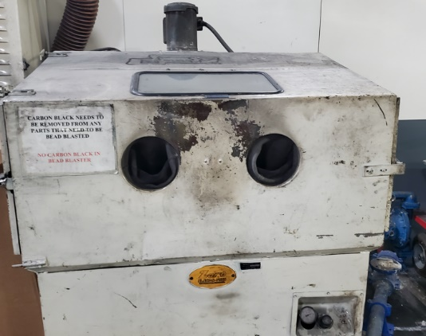  Bead Blaster |  | Risk of eye injury or hand injury. | Make sure air pressure is set correctly and there are no holes in the protective gloves. Close access door before starting machine. | Apply practical knowledge and lessons l | AP Training, Post Training, Post Safety rules
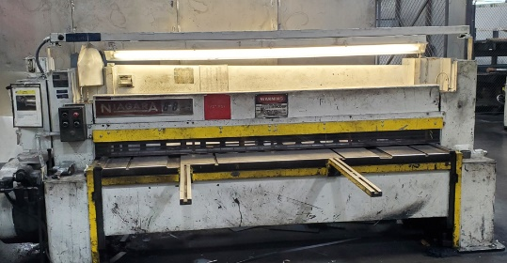  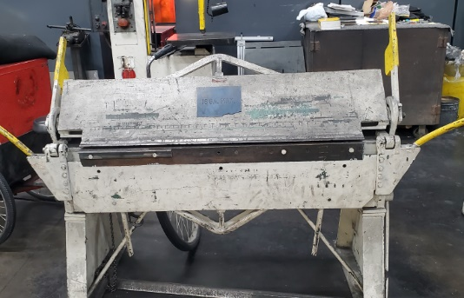  (2) Metal brake |  | Risk of metal shavings in eye or cut by metal shavings. Hand injury risk if not careful when operating machine | Certification is required to operate  Wear PPE as required. | Apply practical knowledge and lessons l | AP Training, Post Training, Post Safety rules
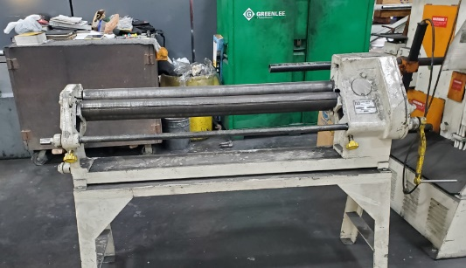  Metal roll press |  | Risk of metal shavings in eye or cut by metal shavings. Hand injury risk if not careful when operating machine | Certification is required to operate  Wear PPE as required. | Apply practical knowledge and lessons l | AP Training, Post Training, Post Safety rules
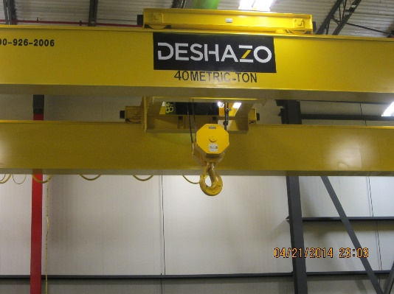 |  | Use caution when operating any overhead crane. | Certification is required to operate Only certified personnel should operate overhead cranes. | PPE, training, attention to detail Post training, Post Safety rules | Post Training, Post Safety rules

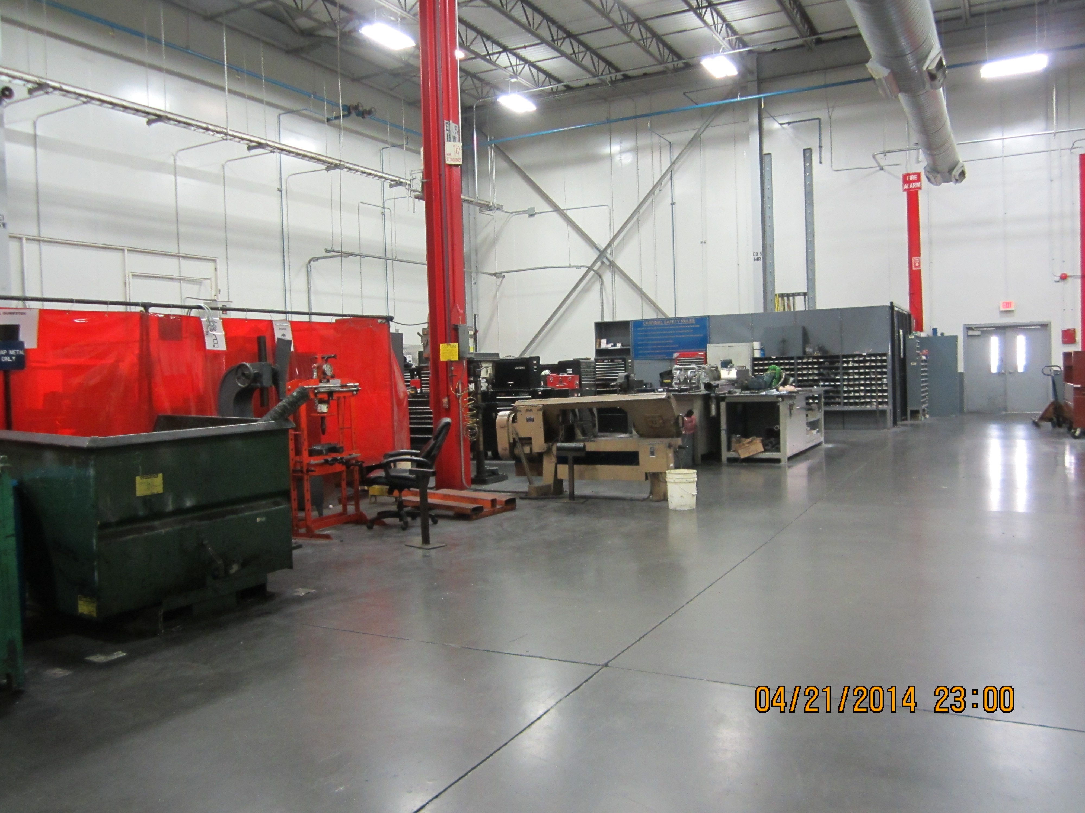
STEP: US8 N Central Shop
Location: US8 NC Shops
Machine: All NC Machinery
Activity: Machine Operations
ENVIRONMENT
DOCUMENT Refs

All scrap materials are recycled when possible!
See page 36 of this document for location of all Training, LOTOTO and MSDS documentation!

No particular Medical Supervision
PARTICULAR MEDICAL SUPERVISION - EMERGENCIES

HAZARDS

INSTRUCTIONS - PRECAUTIONS
Mobile equipment moving things in shops!
Mobile equipment moving things in shops! | Mobile equipment moving throughout the shops. Be careful when walking about.
Overhead crane operating! | Use caution when any cranes are in use! Be careful with loads. Make sure they are handled correctly! Notify others in the area of crane usage so they will be aware! Use a “spotter” when practical!
Lots of places to get hand, eye injuries! | Use caution when placing hands around moving equipment! Correct PPE is mandatory at all times.
Electrical Shock hazards! | Use safe methods when working around electrical test equipment!
Arc flash dangers! | Protect yourself and others from Arc Flash! Wear eye protection and provide shielding from arc!

Safety Rules
Security Emergency

41911

REFLEX ACTION SHEET
METAL LATHE

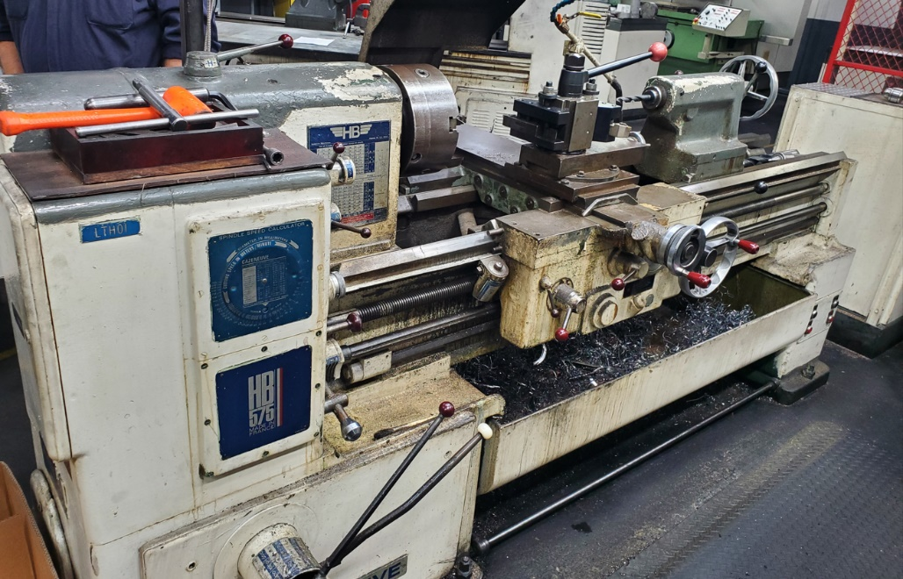

Action A – PPE = Safety glasses & gloves (use caution when gloved hands ae placed near the work or cutting tool

Action B – Certification is required to operate any lathe

Action C – Make sure the work is secured in the chuck

Action D – Make sure the cutting tool is secured in the tool post

Action E – Make sure correct feed/speed are selected when operating in automatic

Action F – Make sure the steady rest is properly secured when it is being utilized

REFLEX ACTION SHEET
Miller Spectrum 2050 (Plasma Cutter)
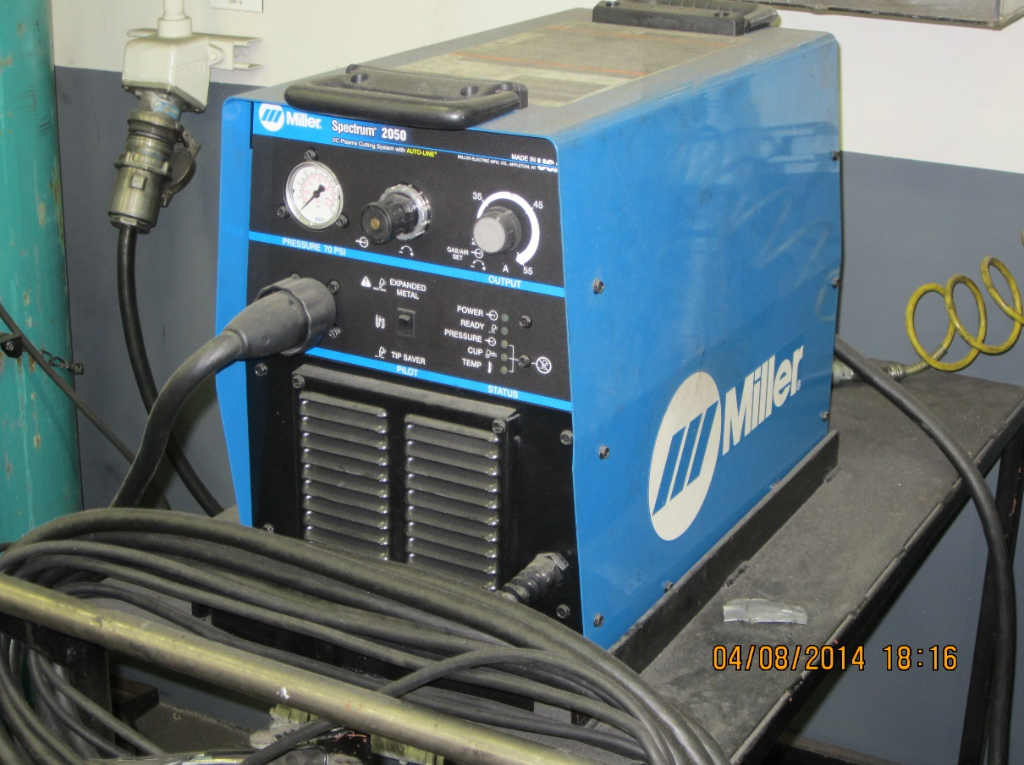

Action A – PPE = Welding hood (with correct lens) gloves and other protective clothing that may be required

Action B – Certification is required to operate welding machines

Action C – Arc flash protection in place to shield surrounding areas

Action D – Machine controls set to correct settings

Action E – Fire watch in place & cold fire extinguishing agent present

REFLEX ACTION SHEET
Miller Matic 250X Wire Feed Welder
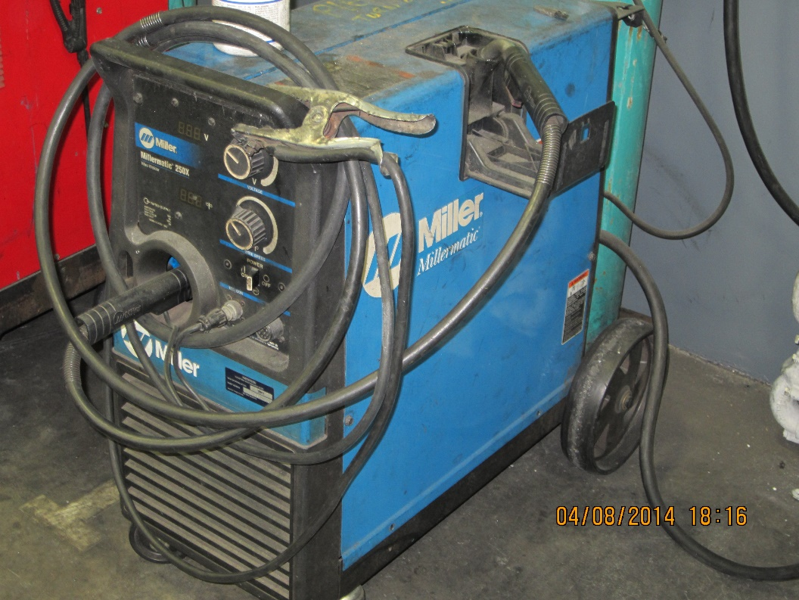

Action A – PPE = Welding hood (with correct lens) gloves and other protective clothing that may be required

Action B – Certification is required to operate welding machines

Action C – Arc flash protection in place to shield surrounding areas

Action D – Machine controls set to correct settings

Action E – Fire watch in place & cold fire extinguishing agent present

REFLEX ACTION SHEET
Econoline Pneumatic Bead Blaster
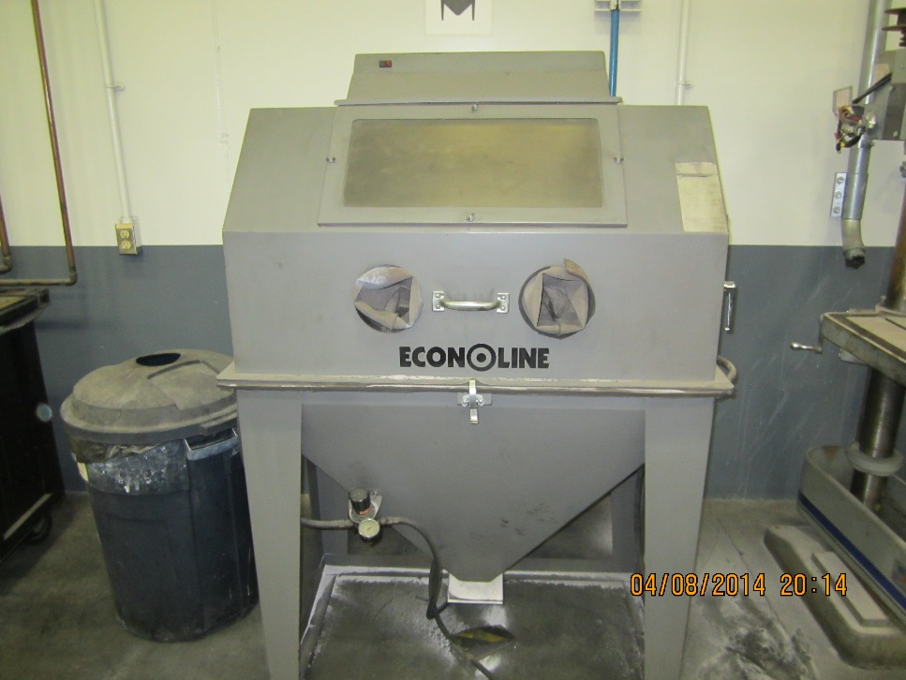

Action A - PPE = safety glasses, hearing protection

Action B - Make sure the viewing glass is clean

Action C - Make sure the access doors are closed and latched

Action D - Make sure the aspiration is running

Action E - Make sure there are no holes in the protective gloves

REFLEX ACTION SHEET
Wet Parts Washers
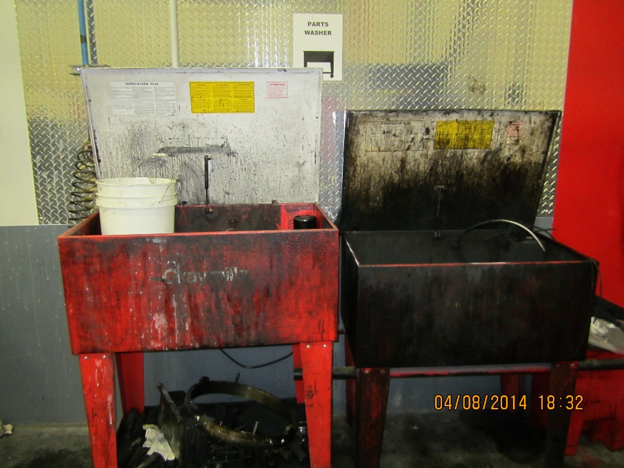

Action A - PPE = safety glasses & latex gloves

Action B - Make sure the washer nozzle is pointed in a safe direction before starting the machine

Action C - Use the correct cleaning tools (brush, scraper, scotch brite, etc.) no rags!

Action D - Be sure to turn off power & close the lid when finished!

Action E - No open flames near parts washer

REFLEX ACTION SHEET
Lincoln IdealArc 250 Heli-Arc

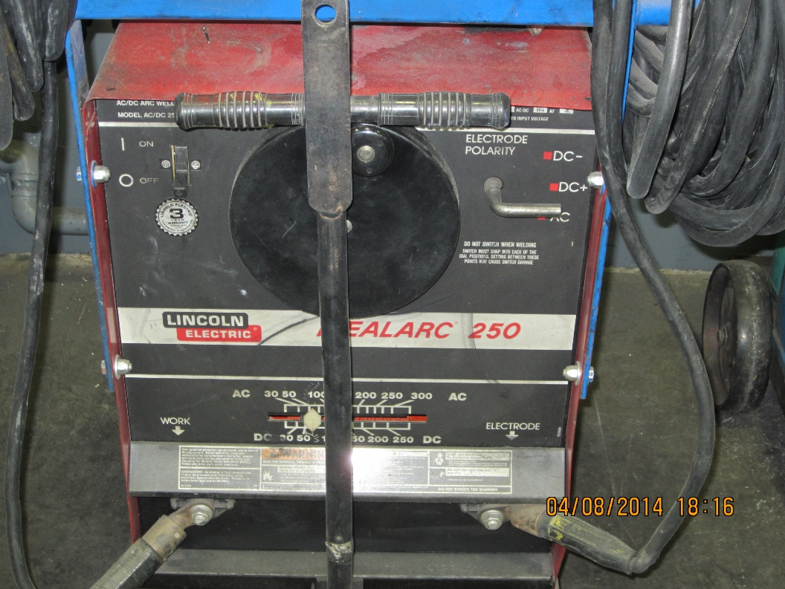

Action A – PPE = Welding hood (with correct lens) gloves and other protective clothing that may be required

Action B – Certification is required to operate welding machines

Action C – Arc flash protection in place to shield surrounding areas

Action D – Machine controls to correct settings

Action E – Fire watch in place & cold fire extinguishing agent present

REFLEX ACTION SHEET
Miller Syncrowave 250 DX (Wet Tig Rig)

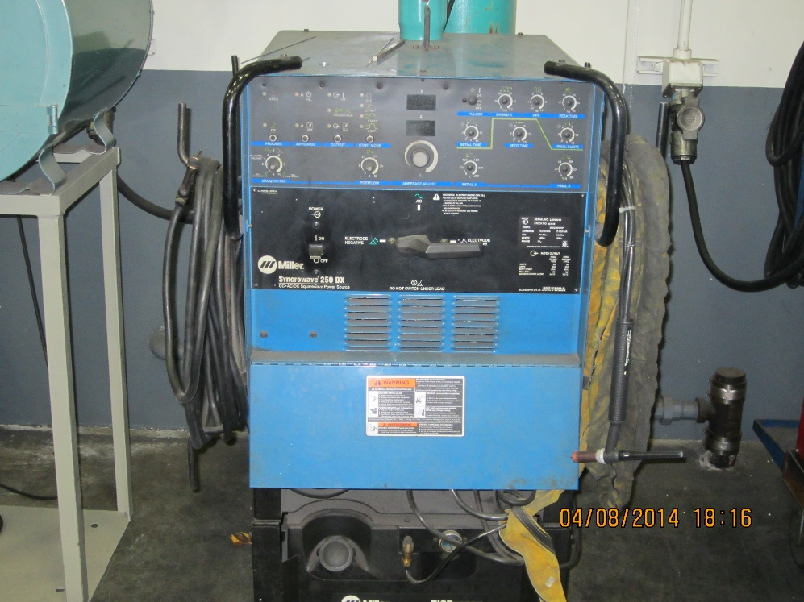

Action A – PPE = Welding hood (with correct lens) gloves and other protective clothing that may be required

Action B – Certification is required to operate welding machines

Action C – Arc flash protection in place to shield surrounding areas

Action D – Machine controls to correct settings

Action E – Fire watch in place & cold fire extinguishing agent present

REFLEX ACTION SHEET
Oxy-Acetylene Rigs

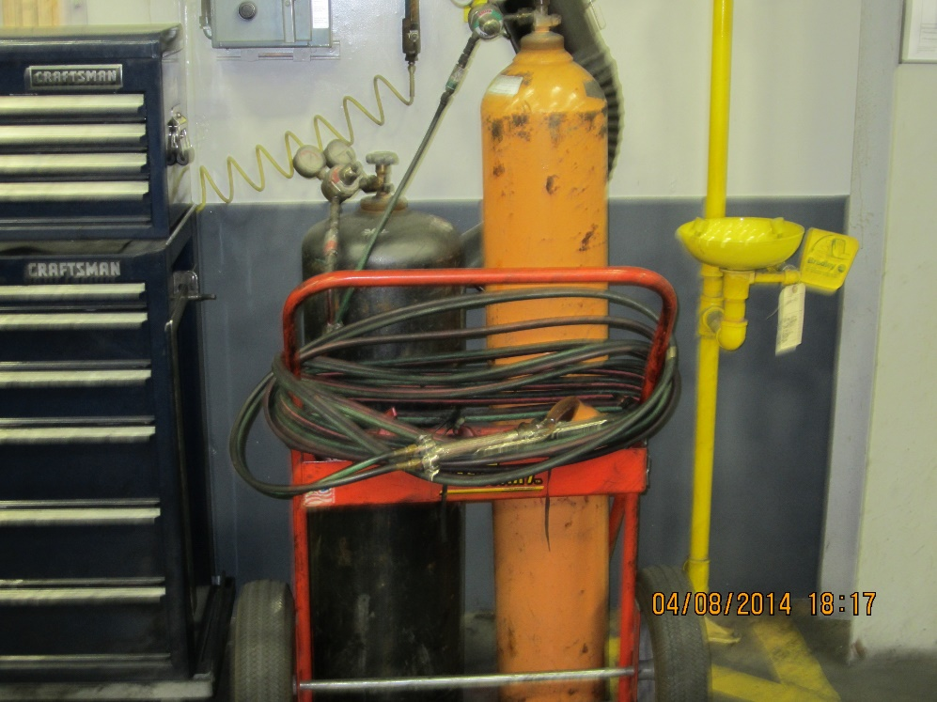

Action A – PPE = Welding hood (with correct lens) gloves and other protective clothing that may be required

Action B – Certification is required to operate welding machines

Action C – Arc flash protection in place to shield surrounding areas

Action D – Machine gauges to correct settings

Action E – Fire watch in place & cold fire extinguishing agent present

REFLEX ACTION SHEET
JET 15 ton Hydraulic Press
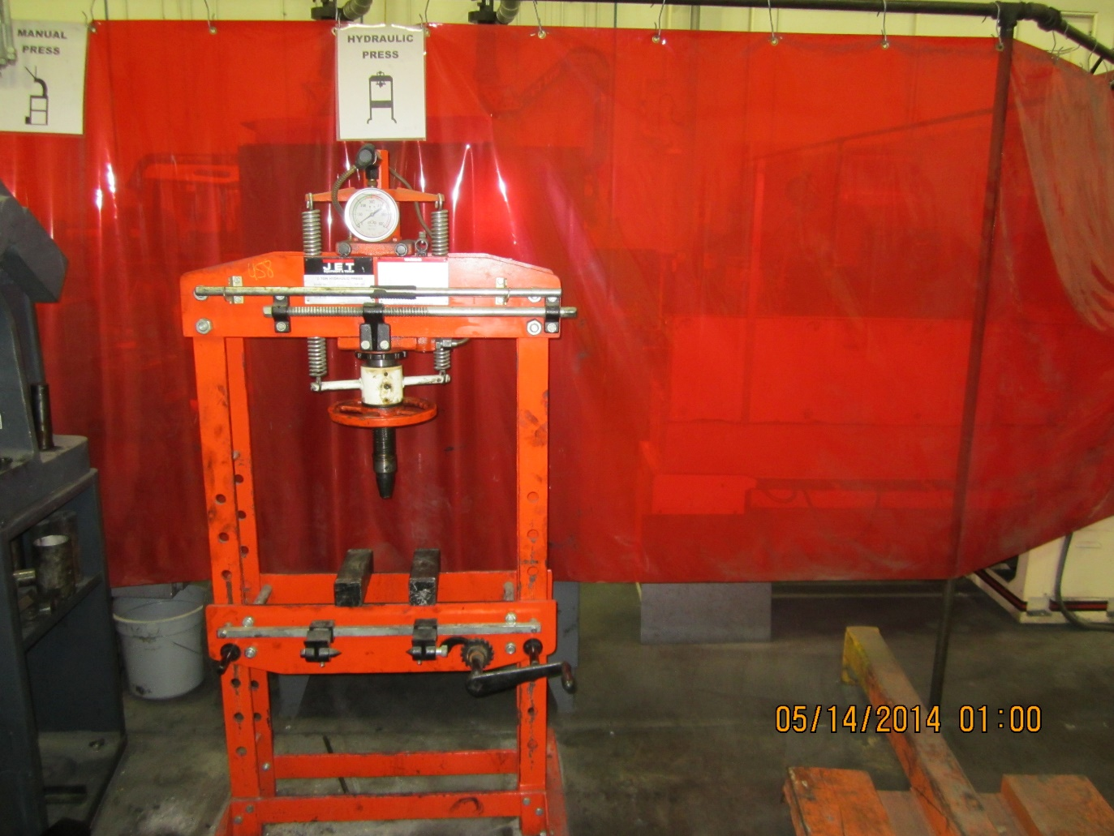

Action A – PPE = Safety glasses & gloves

Action B – Certification is required to operate this press

Action C – Make sure pressure is set correctly

Action D – Make sure work is secured so it won’t slip out & hurt someone

Action E – Make sure others close by know you are about to operate the press

Action F – Make sure hands are clear when beginning to apply pressure

REFLEX ACTION SHEET
DAKE Arbor Press
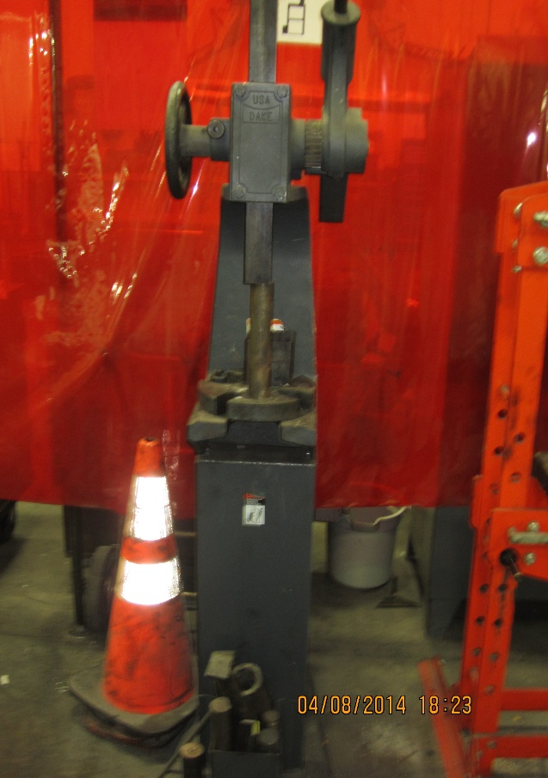

Action A – PPE = Safety glasses & gloves

Action B – Make sure work is properly secured

Action C – Use caution when operating pull handle so that it doesn’t fall & make contact with operator or others

Action D – Make sure hands are clear when applying pressure with pull handle

REFLEX ACTION SHEET
Kalamazoo Band Saw

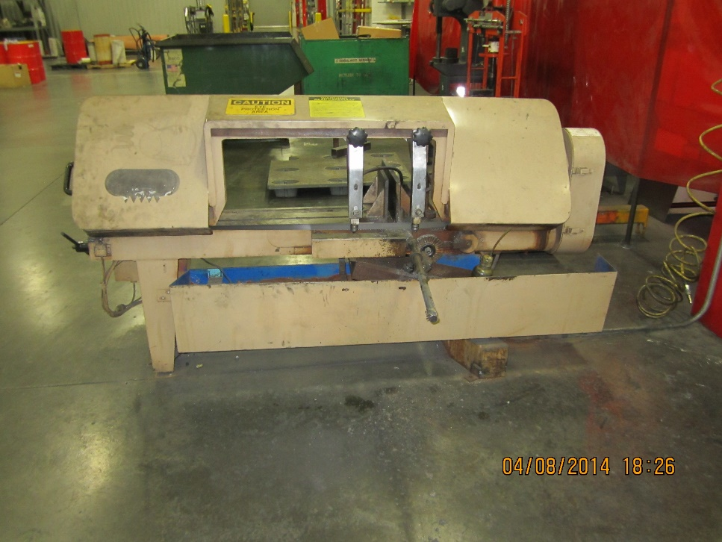

Action A – PPE = Safety glasses & gloves

Action B – Certification is required to operate this saw

Action C – Make sure the work is securely clamped

Action D – Make sure the blade support is properly adjusted

Action E – Make sure the downward motion is adjusted so that it doesn’t feed too fast

Action F – If using coolant, adjust flow as necessary

REFLEX ACTION SHEET
JET Drill Press

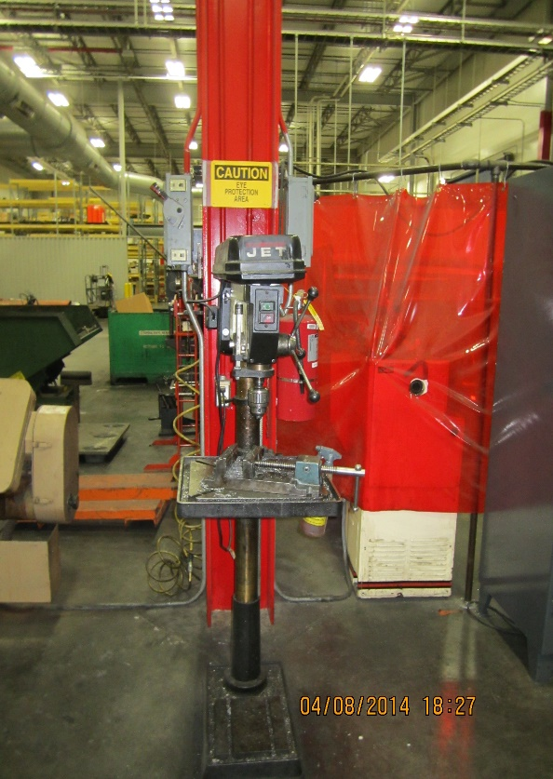

Action A – PPE = Safety glasses & gloves (use caution when placing gloved hands near the chuck or drill bit

Action B – Make sure the work is properly secured

Action C – If so equipped, make sure feed/speed is set correctly

REFLEX ACTION SHEET
Rigid Pipe Threader

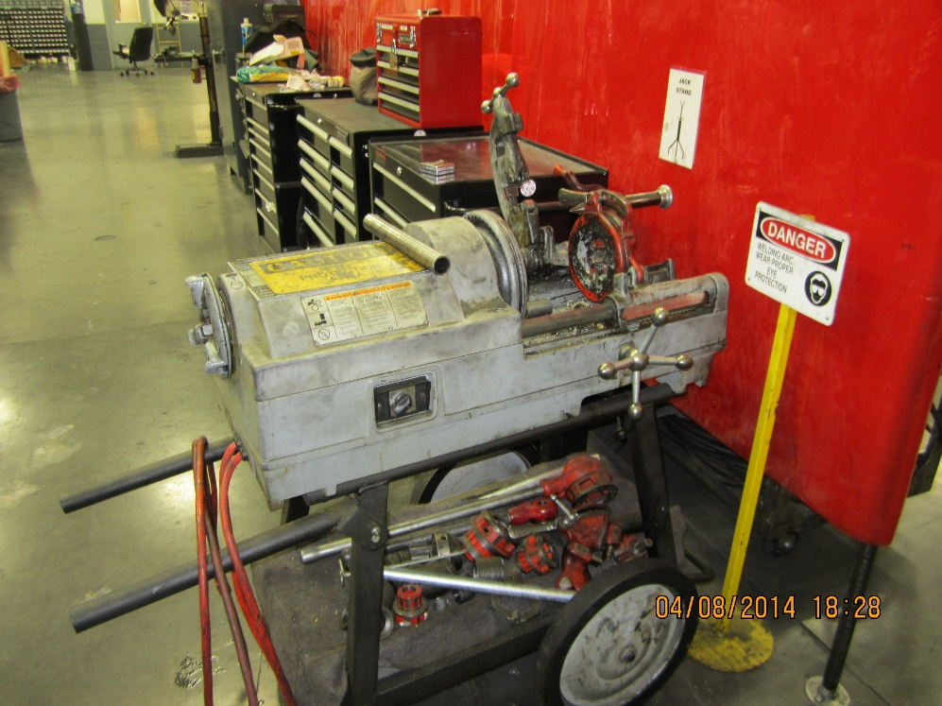

Action A – PPE = Safety glasses & gloves

Action B – Make sue work is secured in chuck

Action C – Make sure threading die is properly adjusted and secured

Action D – Set coolant flow

Action E – Observe and control thread length

REFLEX ACTION SHEET
Clausing 20 Drill Press

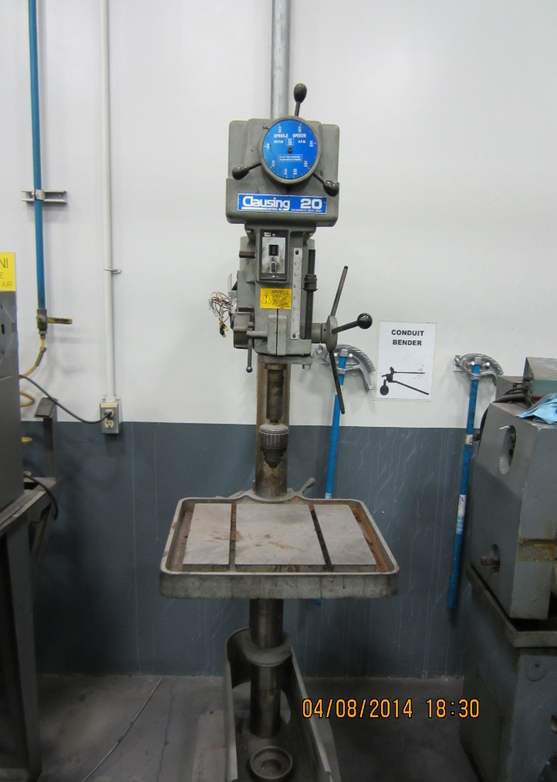

Action A – PPE = Safety glasses & gloves (use caution when placing gloved hands near the chuck or drill bit

Action B – Make sure the work is properly secured

Action C – If so equipped, make sure feed/speed is set correctly

REFLEX ACTION SHEET
GRIZZILY Lathe

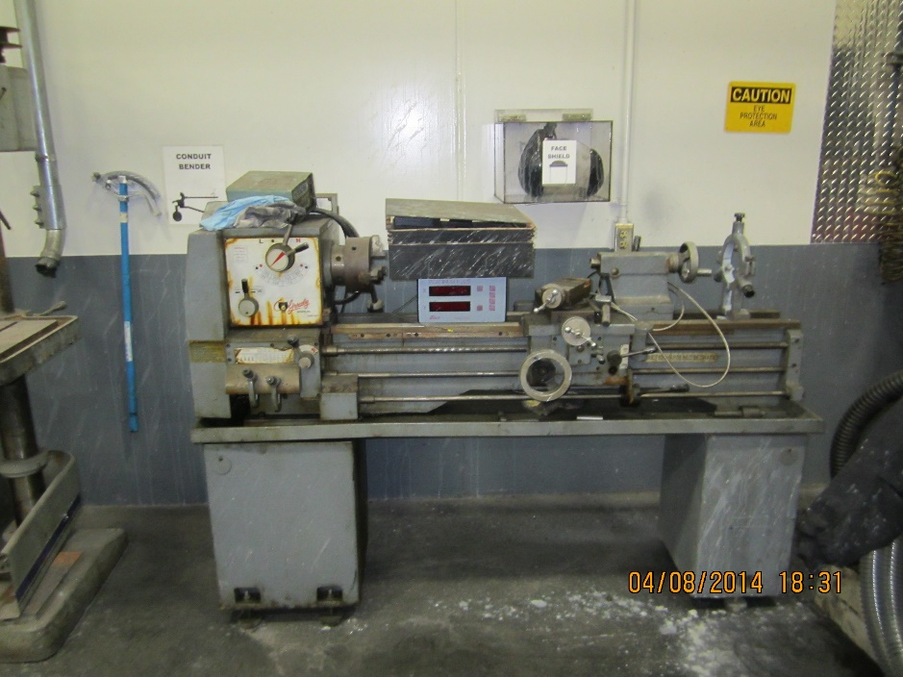

Action A – PPE = Safety glasses & gloves (use caution when gloved hands are near the work or the cutting tool)

Action B – Certification is required to operate this lathe

Action C – Make sure the work is secured in the chuck

Action D – Make sure cutting tools are secured in the tool post

Action E – Make sure correct feed/speed are selected when operating in automatic

Action F – Make sure “steady rest” is properly secured when it is utilized

REFLEX ACTION SHEET
Porter Cable Pedestal Grinder

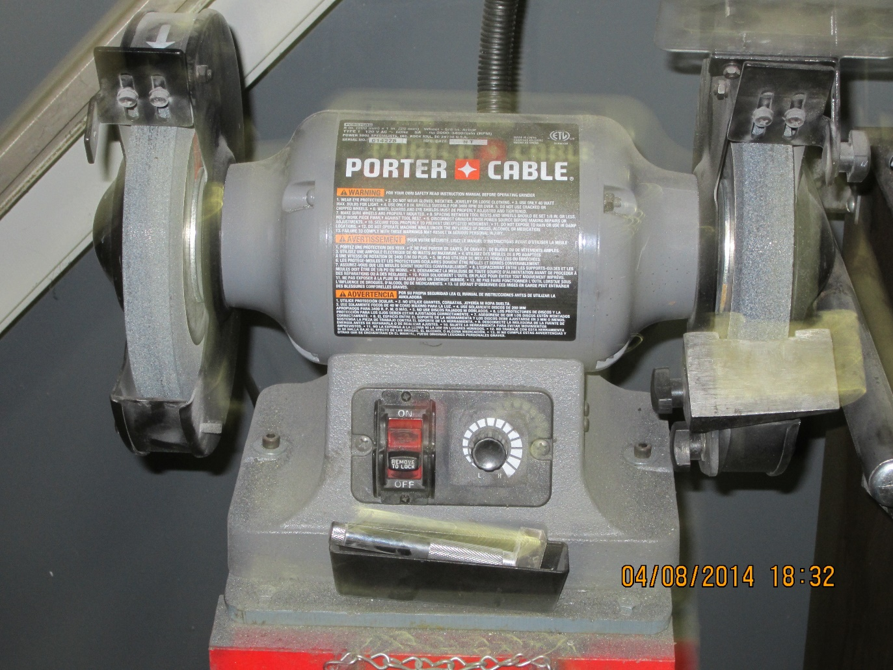

Action A - PPE = safety glasses, face shield & gloves (use caution when placing gloved hands near grinding wheel)

Action B - Prior to use, make a visual inspection of the grinding wheel looking for damage or misuse

Action C - Make sure the gap between the work rest and the grinding stone is set at 1/8 “

Action D - Make sure the gap between the guard and the grinding stone is set at ¼”

REFLEX ACTION SHEET
JET Belt/Disc Sander
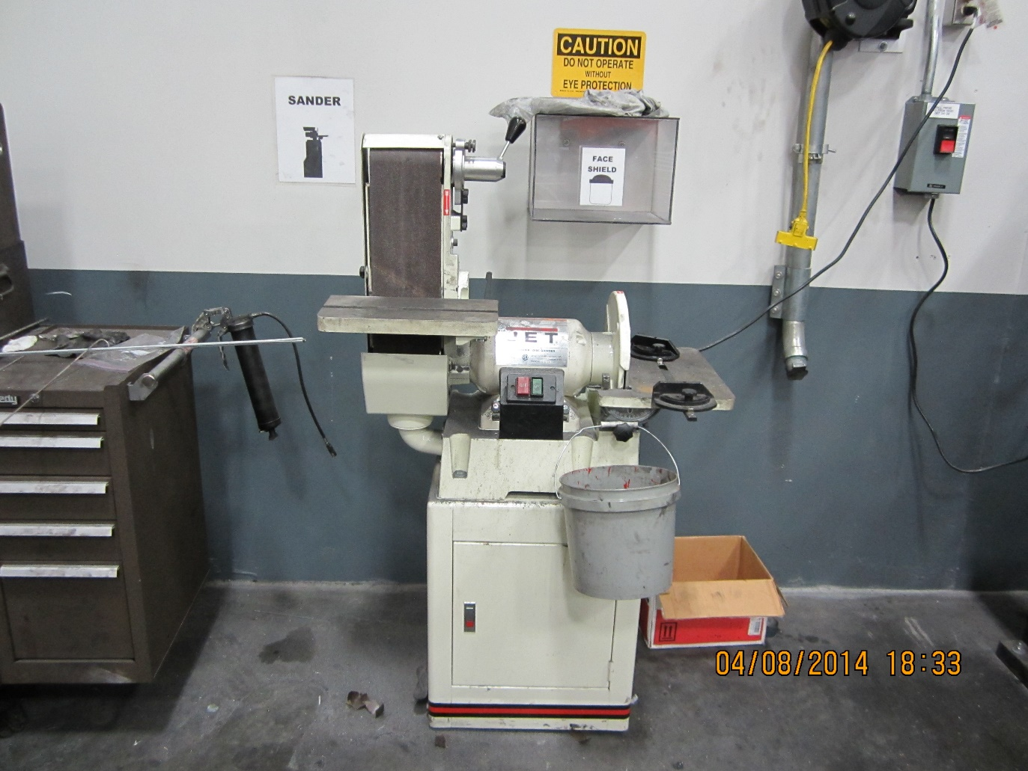

Action A - PPE = safety glasses, face shield & gloves (use caution when placing gloved hands near sanding disc)

Action B – Inspect belt/disc for damage and replace as necessary

REFLEX ACTION SHEET
Drill Press/Mill

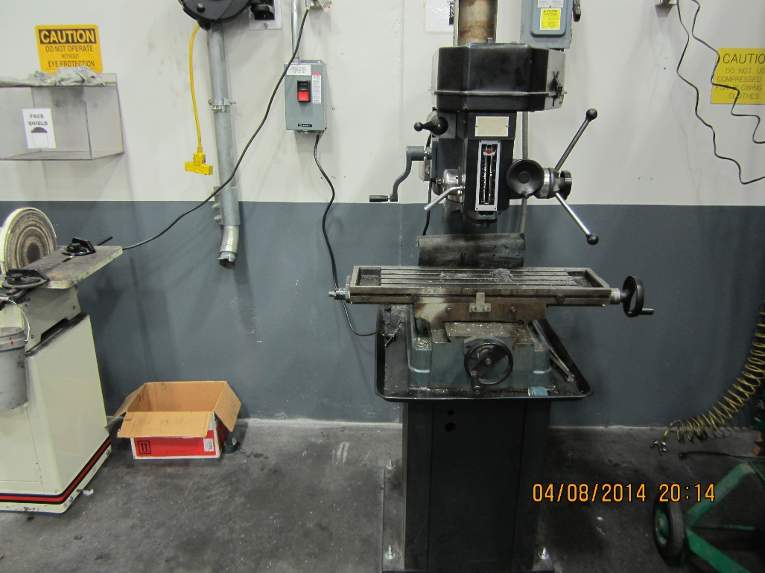

Action A – PPE = Safety glasses & gloves ( use caution when gloved hands are near work or the chuck)

Action B – PPE = If using this device as a “mill” certification is required

Action C – Make sure the work is securely clamped to the work table

Action D – Make sure the drill bit/cutting tool is securely in the chuck

Action E – If automatically positioning the work table, make sure to observe the travel

Action F – If moving the work table in automatic while cutting, make sure the feed/speed is set correctly

REFLEX ACTION SHEET
Faucault Bearing Heater

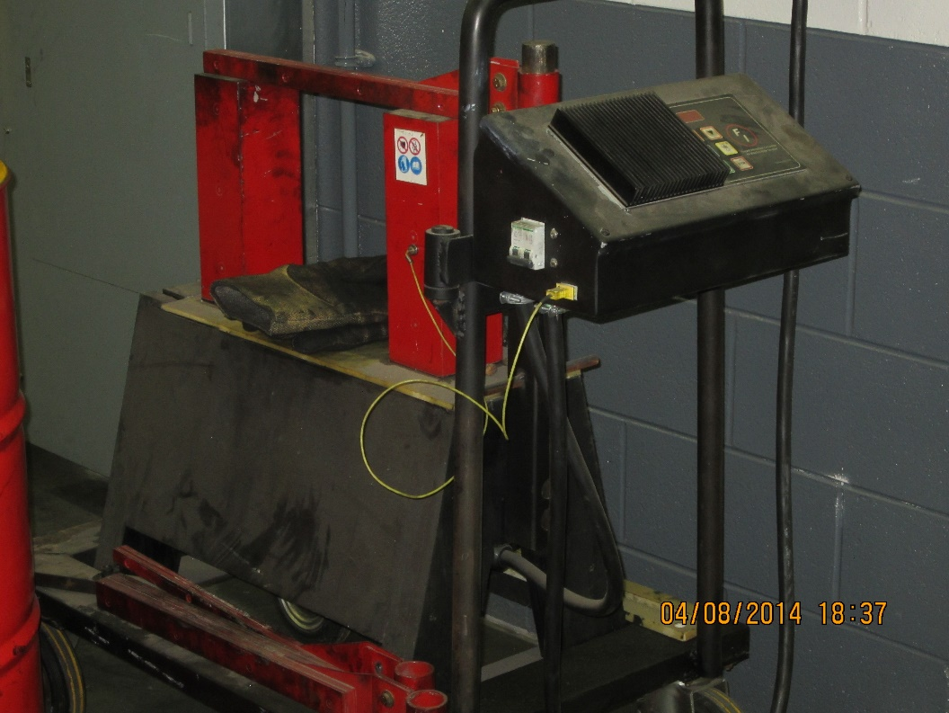

Action A – PPE = Safety glasses & gloves

Action B – Certification is required before operating the bearing heater

Action C – Inspect all cables and connections prior to use

Action D – Make sure the machine is programmed correctly for the bearing you are heating

REFLEX ACTION SHEET
DESHAZO Overhead Crane

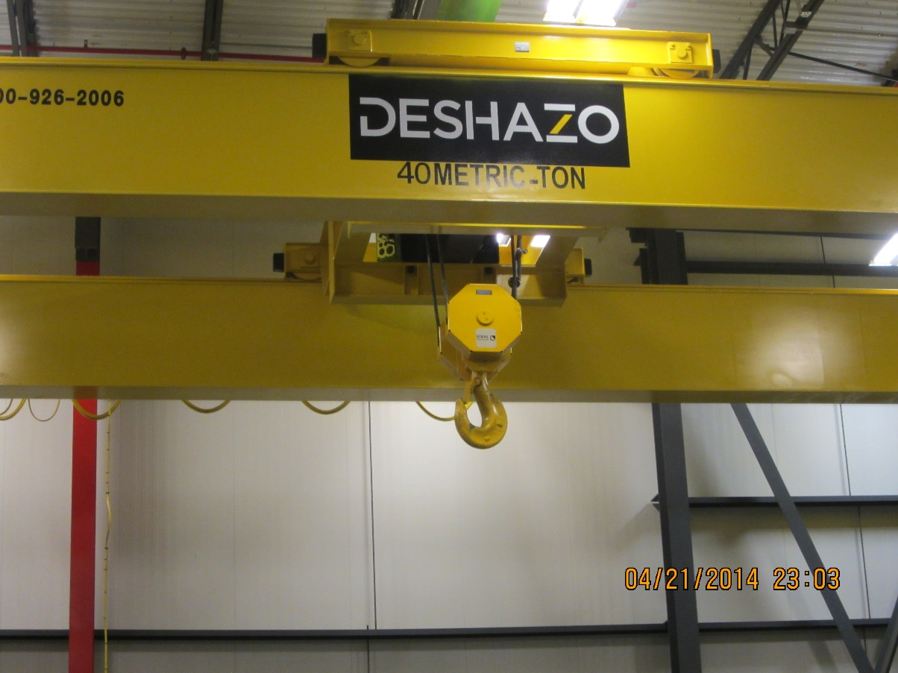

Action A - PPE = safety glasses & gloves

Action B - Certification is required prior to using any overhead crane

Action C- Use caution when moving crane, crane trolley or the lifting hook

Action D - Make sure the crane lifting capacity is not exceeded (capacity listed on crane)

Action E - Inspect all lifting devices for damage prior to use

Action F - Use proper lifting devices: chokers (steel or nylon), spreader bars, etc.

Action G - Make sure load is balanced before lifting

REFLEX ACTION SHEET
COACTIVITY MANAGEMENT

Purpose:
The primary objective of coactivity management is to protect people from risks caused by activities other than their own or by their coactivity in the same work area (in time and space).

Scope:
It covers all on-site interventions where employees may work together or in the same area (production, adjustment, maintenance, quality measurements, storage area, construction activities and areas, start-up, cleaning, etc.). It is applicable to employees, contractors and visitors.

Coactivity:
- Case n°1: An employee generates risks to any other employee present in the area
Examples:
  - Falling parts or tools during maintenance
  - Noise caused by the use of portable tools

- Case n°2: The intervention of an employee leaves a risk in the area in which it intervened. Any other employee who will come into this area is then exposed to this risk.
Examples:
  - Oil traces on the ground after disassembly of a hydraulic cylinder
  - Electrical cabinet open, under load
  - Mechanical guard not re-assembled
- Case 3: Coactivity itself generates a risk that would not exist if the employee acted separately.
Examples:
  - Uncoordinated interventions on complex or large machines :
- Using a robot with another intervention in the same area
- Simultaneous interventions on a curing press and on the curing systems in the basement
  - Intervention of a forklift or lifting device on a workstation
  - Diagnostic phase requiring energy to understand the malfunction
  - Dimension change with activity on two side of a line / equipment

Communication :
Coactivity situation communication is required,
- Know appropriate number of participants
- The complexity of the activities.
- Communications may range from simple verbal or non-verbal exchanges between two co-workers to
- Formal “toolbox” meetings prior to a maintenance operation or dimension change
- Job Hazard Analysis
Identify a “leader” for the job / task
Complete a hazard analysis with team (verbally, SS4, degraded safety)
Communicate during coactivity situations
Discuss communication expectations

Reflex Action Sheet
Moving equipment to and from height

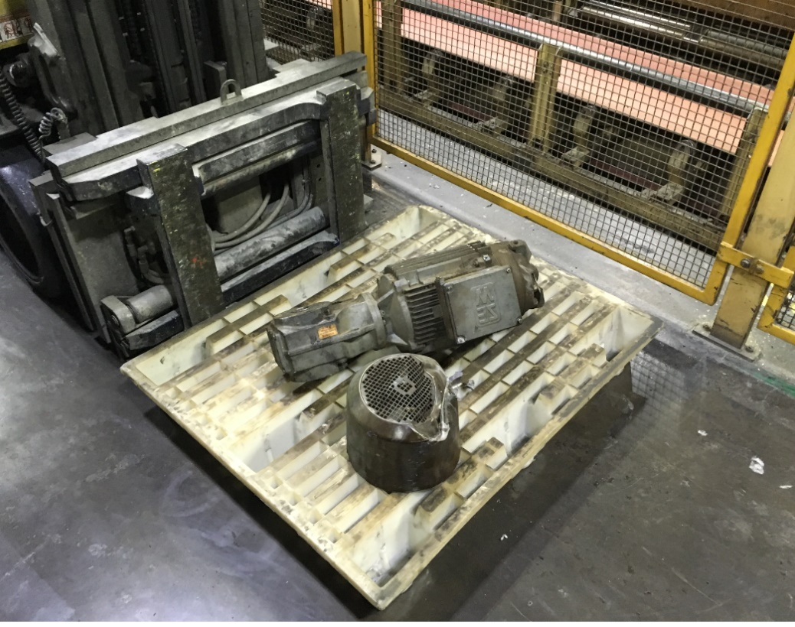

Action A – When feasible use a hoist and proper rigging practices for movement of equipment
Action B – Cordon off safe area under load to prevent pedestrian and vehicle from passing under.
Action C – I forklift is used, white pallets are not suitable carrying load.
Action D – Only pallets with crossmember should be used.

 |  | Document Location or Link
Work Instruction |  | Reference BIB DOC: N/A
Operator Certification Form |  | Reference BIB DOC : N/A
LOTOTO Matrices |  | Reference BIB DOC : US8 NZR Group 83 LOTOTO
LOTOTO PLD |  | Reference BIB DOC : US8 NZR Group 83 LOTOTO
LOTOTO Instructions |  | Reference BIB DOC : US8 Lockout Documents > US8 LOTO > US8 General LOTOTO
Potential Chemical Exposure Information |  | Refer to the MSDS for the facility for questions about any Chemical exposure on this post!  The MSDS finder is found on the US2/8 Home Page and shown as an ICON. Note: this ICON has listed on it the “username” and “password”. Click on the ICON, enter Username and Password to launch. In the search clue box enter the Chemical Name or a “search clue” to see the MSDS for the chemical in question!  
PPE Requirements |  | For specific PPE requirements:  As specified in the US2/8 Plant General Safety Rules and all safety rules outlined in this document
Machine Risk Analysis (TLK720) |  | Reference BIB DOC: US2-US8 SMEP Pgms / Documents / ARMs & TLK720 / 7 ARMs Audits & Self Assessments / 5 Group Z US8

